H.T No
Regulations:
A18

Sreenidhi Institute of Science and Technology
(An Autonomous Institution)
Code No:7BC02 Date: 14-Feb-2025 (FN)

B.Tech I-Year II- Semester External Examination, Feb-2025 (Supplementary)
ENGINEERING GRAPHICS AND DESIGN(CIVIL, CSE, IT and ECM)

Time: 3 Hours Max.Marks:70

Note: a) No additional answer sheets will be provided.
b) All sub-parts of a question must be answered at one place only, otherwise it will not be valued.
c) Missing data can be assumed suitably.
Bloom's Cognitive Levels of Learning (BCLL)

Remember | L1 | Apply | L3 | Evaluate | L5
Understand | L2 | Analyze | L4 | Create | L6

Part - A Max.Marks:20

Answer all QUESTIONS.

 |  | BCLL | CO(s) | Marks
1 | Define engineering drawing. Why drawing is called the universal language of engineers? | L1 | CO1 | [2M]
2 | Differentiate between first angle and third angle projection methods. | L1 | CO2 | [2M]
3 | Define oblique plane? | L1 | CO3 | [2M]
4 | Explain about auxiliary inclined planes and auxiliary vertical planes. | L2 | CO4 | [2M]
5 | Define orthographic projection? | L1 | CO5 | [2M]
6 | Write the basic commands used in AutoCAD? Write limitations. | L1 | CO6 | [2M]
7 | Explain the Concept of Scale Factor. | L2 | CO1 | [2M]
8 | Explain the importance of sectional views and development of solids. | L2 | CO3 | [2M]
9 | What is isometric axis? | L2 | CO5 | [2M]
10 | What do you mean by RF? What is the unit of RF? | L2 | CO6 | [2M]

Part – B Max.Marks:50
ANSWER ANY FIVE QUESTIONS. EACH QUESTION CARRIES 10 MARKS.

 |  |  | BCLL | CO(s) | Marks
11. |  | A fixed-point F is 75mm from a fixed straight line. Draw the locus of a point P moving in such a way that its distance from the fixed straight line is 2/3 times its distance from F. Name the curve. Draw normal and tangent at a point 50mm from F | L3 | CO1 | [10M]
12. |  | Draw the projections of the following points on the same ground line, keeping the projectors 20mm apart.  (a) Point C in the VP and 40mm above HP.  (b) Point D 25mm below the HP and 25mm behind the VP.  (c) Point E 15mm above the HP and 50mm behind the VP.  (d) Point F 40mm below the HP and 25mm in front of the VP.  A point P is 20mm below HP and lies in the third quadrant. Its shortest distance from xy is 40mm. Draw its projections | L4 | CO2 | [10M]
13. |  | Draw the projection of a circle of 60mm diameter resting on the V.P. on a point on the circumference. The plane is inclined at 45⁰ to V.P. and perpendicular to the H.P. The center of the plane is 40mm above H.P | L3 | CO3 | [10M]
14. |  | A hexagonal prism of side of base 30mm and height 60mm is resting on HP, with one of its base edge parallel to V.P. Right half of the solid is cut by upward plane inclined at 60⁰ to the ground and starting from the axis and 30mm below the top end. The left half of the solid is cut by a plane inclined at 30⁰ to H.P downwards from the axis. The two section planes are continuous. Draw the development of lower portion. | L4 | CO4 | [10M]
15. |  | Draw the isometric view of a hexagonal prism, with side of base 25mm and axis 60mm long, the prism is resting on its base on H.P. with an edge of the base parallel to V.P. | L3 | CO5 | [10M]
16. |  | Draw the Front view Top view and side view for the following figure.  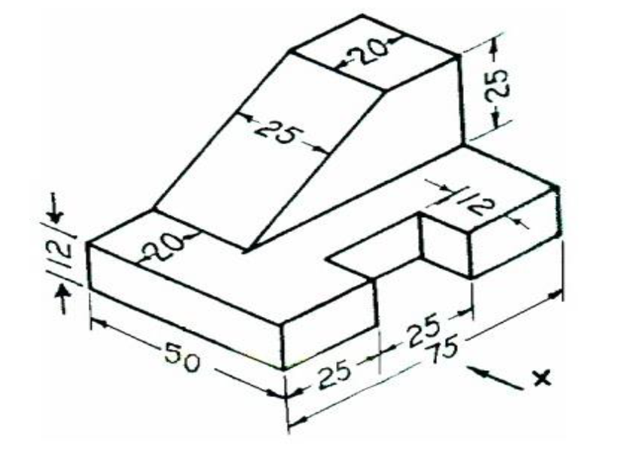 | L4 | CO6 | [10M]
17. |  | A circle of 50mm diameter rolls along a straight line without slipping. Draw the curve traced out by a point P on the circumference, for one complete revolution of the circle. Name the curve. Draw a tangent to the curve at a point on it 40mm from the line. | L4 | CO1 | [10M]
18. | a) | Draw Sectional Top View of a square prism of base 40mm and height 60mm rests with its base on the HP such that one of its edges is inclined at 30° to the VP. A section plane inclined at 60° the VP and perpendicular to the HP bisects one of the rectangular faces. | L1 | CO4 | [5M]
 | b) | Draw isometric view of a circle diameter 30mm. | L1 | CO5 | [5M]
-- 00 -- 00 –

